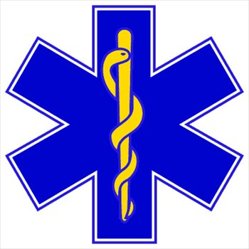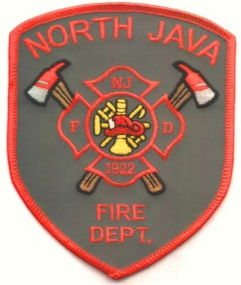***North Java Fire Department***

*4274 Route 98*

*North Java, NY  14113*

*Phone: (585) 535-9950*

**Tractor Pull Classes**

**STOCK Enhanced 3000RPM Max**

4500 4500

5500 5500

6500 6500

8500 8500

10500 10500

12500 12500

14500 14500

Street Legal Diesels

Gas Engine Class

**Pro Farm Pulling**

Light Pro Farm

Light Pro Stock

2.6 Diesel Pick Up

Semi’s